Archdiocese of Wellington & St Columban’s Mission Society

Invitation

Year of Faith
Celebrating Faith and Mission

Cathedral of the Sacred Heart Wellington
2:00pm Sunday 21 July 2013

Celebrating 175 Years of Mission
Honouring the Missionaries
Remembrance of all those who have come on mission service since 1838
Recognition of New Zealanders who have served in overseas mission situations

Father Francis Vernon Douglas (1910 – 1943)
Honouring the Memory of an Inspiring Missionary
Recalling the Story of Father Douglas, Missionary to the Philippines
Blessing of Memorial Carved Stone for Retention in the Cathedral
Entrusting the Taonga to Archbishop John Dew and the Archdiocese

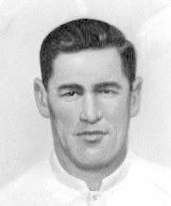

Reflection on Columban Mission Experience
What Have We Learned Since 2nd Vatican Council?
Father Noel Connolly, Columban Mission Institute, Sydney, Australia

Father Michael Gormly (04) 567 7216

Bulletin Notice

Year of Faith
Celebrating 175 Years of Faith and Mission
in Aotearoa New Zealand

Cathedral of the Sacred Heart Hill Street Wellington
Sunday 21st July at 2:00pm

Late July marks the 70th anniversary of the heroic death in the Philippines of the local missionary priest, Francis Vernon Douglas.

A stone carving to honour his memory will be presented on this occasion to Archbishop John Dew for a place in the Cathedral.

The art piece will also honour all who came to New Zealand in mission service, plus those who now serve in overseas mission situations.

A reflection on mission experience over the decades will be presented by Father Noel Connolly from the Columban Mission Institute, Sydney.

The anniversary will also be featured at a commemorative weekend in late June in Johnsonville, the home parish of Father Douglas.

Father Michael Gormly Columban Mission (04) 567-7216

Columban Mission
Wellington New Zealand

Year of Faith in New Zealand
Celebrating 175 Years of Mission and Looking Ahead
The prime aim of the Year of Faith is surely to promote a renewed sense of mission. It is a time to affirm that dioceses, parishes and schools are at their best when they run with a spirit of gospel mission. The 175 year history of the Catholic Church in Aotearoa New Zealand bears this out.
Pope Francis is already speaking of mission in fresh, positive and encouraging terms. He suggests the church could well emerge from inward distractions and move out to the peripheries, not only in a geographic sense, but across what he calls the ‘existential edges.’
The Year of Faith puts pressure on the Catholic community to re-think what mission is about. For this purpose I have invited Father Noel Connolly, a mission expert from the Columban Mission Institute, to speak at the Cathedral on the afternoon of Sunday 21 July. Theme: What has been Learned from Missionary Experience since the 2nd Vatican Council?

Celebrating New Zealand Missionaries
Honouring the Memory of Father Francis Vernon Douglas
Late July also marks the 70th anniversary of the heroic death of the New Zealand missionary, Father Francis Vernon Douglas. A stone piece to honour his memory will be presented on 21st July to Archbishop John Dew for a place in the Wellington Cathedral.
While the carved stone evokes the story of one inspiring missionary, the memorial honours all who came to serve this land and people in mission service, and those who now serve in overseas situations with distinction.
The carved stone will first be featured at a commemorative weekend in late June in Johnsonville, the home parish of Father Douglas. Then, prior to final installation at Hill Street, the art piece will travel elsewhere to promote a message of faith and mission.
My hope for late July is twofold: first, to highlight the importance of mission service as the New Zealand church seeks meaning in a Year of Faith; and second, to re-tell the story of Father Douglas for the benefit of a church community in search of inspiration.

Archdiocese of Wellington & St Columban’s Mission Society

Year of Faith
Celebrating Faith and Mission

Cathedral of the Sacred Heart Wellington
2:00pm Sunday 21 July 2013

[Tentative Programme]

- Celebrating 175 Years of Mission and Honouring Missionaries [Karanga ]

- Mission service is highlighted and celebrated in the Year of Faith
- Remembrance of all who have come to serve this land and people in mission service since 1838
- Presentation of a woven flax to a representative of the many missionaries who have arrived
- Recognition of Kiwi missionaries who have served with distinction in overseas situations [Waiata]
- Presentation of a woven flax to a representative of past and present missionaries (Karakia)

- Honouring the Memory of Father Francis Vernon Douglas (1910-1943)

- The life, mission and heroic death of Father Douglas: Father Michael Gormly.

- Carved marble memorial to honour Father Douglas is unveiled and blessed [Waiata]
- The art piece is entrusted to the Archbishop and the Archdiocese for retention in the Cathedral
- A formal word of appreciation is made by Archbishop John Dew (Waiata & Karakia)

- As we honour Father Frank Douglas on the 70th anniversary of his death.
- Memorial presentation to a representative of the Douglas Family (Mrs Maria McIlroy)
- Memorial presentation to Mrs Patricia Brooks, author of “With No Regrets”, life of Father Douglas
- Memorial presentation to the Francis Douglas Memorial College and the New Plymouth community
- Memorial presentation to the Parish Community of Sts Peter and Paul, Johnsonville
- Memorial presentation to Mr Michael Pervan and Art Studio of St John the Baptist, Auckland
- [Waiata]

- What Have We Learned Since 2nd Vatican Council?
Reflection on Columban Oversdeas Mission Experience
- Father Noel Connolly, Columban Mission Institute, Sydney

- Final word of appreciation from Bishop Owen Dolan… and dismissal [E Ihowa Atua / God of Nations]

Father Michael Gormly Columban Mission (04) 567-7216

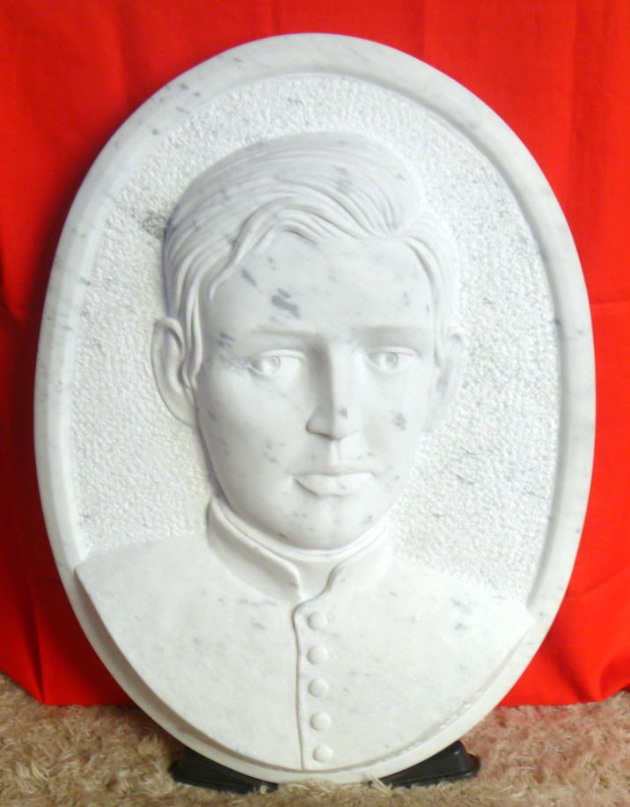

Father Francis Vernon Douglas 1910 - 1943
Carved Marble Memorial Created by the Studio of John the Baptist, Takapuna, Auckland

Honouring New Zealand Missionaries
Father Frank Douglas (1910-1943)
[Basic Focus of Story]
In July 2013 Columbans will mark the 70th anniversary of the heroic death of a colleague, Father Frank Douglas, who is honoured in the New Zealand Catholic Church as an inspirational missionary figure.

Francis Vernon Douglas was born in Wellington on 22 May 1910, into a close, lively, Catholic, working-class family in the suburb of Johnsonville. Leaving school at 14, he worked in the Post Office as a messenger boy. From his youth he was tall, robust, dark-haired and sports-loving. Friends spoke of him as strong-minded, with a fine sense of social and religious duty.
In 1927 he entered the national seminary at Mosgiel, trained for the diocesan priesthood, and was ordained in 1934 for the Archdiocese of Wellington. In 1937, as an energetic and extroverted young priest, he volunteered to join St Columban’s Mission Society. His bishop graciously acknowledged idealism and leadership, fine qualities for overseas mission.
Father Frank was assigned to the Philippines, to Pililla, a lakeside township beyond Manila. It was not an easy assignment, but he made the most of every opportunity, especially in learning the language, and in coming to terms with the culture and unfamiliar customs. The people were poor, and, because of religious indifference church attendance was small.
Life became especially difficult when the Japanese military invaded the Philippines in December 1941. The invading soldiers were intent on containing local resistance, so they kept a close eye on Father Frank, with a suspicion that he was a foreign spy. He was finally arrested in late July 1943 and taken to the neighboring town of Paete.
Along with others, he was interrogated, deprived of sleep, and tortured. Through the whole ordeal, tied to a pillar in the church, he remained silent. After three days, bloodied and bruised, he was bundled away on a truck. It is believed that he died as a result of the beating. But he was never seen again and his body was never found.
The suffering of Father Frank made a deep impression on the town. Here was a strong and brave man who withstood days and nights of horrific punishment. He suffered in silence, not betraying the trust of others. When anger was centred on him, others were spared. Beaten and ill-treated, he was regarded as a kind of saviour.
After the war, reports of his heroic death reached his homeland, New Zealand. The challenging aspects of his dedicated life and heroic death became known, and are remembered still. We are indebted to Patricia Brooks who researched and published the story of Francis Vernon Douglas. Her book, “With No Regrets“, recalls quiet idealism and authentic heroism. To honor his memory, Columbans in New Zealand have commissioned a carved memorial stone to be presented to the Archbishop for the Cathedral in Wellington. On this occasion a reflection on recent Columban missionary experience will be presented.
Father Michael Gormly Coordinator Columban Mission Wellington New Zealand

